World Masters Order form

The kit is available for all SA participants. Please note that the SA selected team will have the SA Masters logo on their kit and all other players will have the SA flag and ‘South Africa’ on the items.

Please email all orders to: [Gobig@mweb.co.za](mailto:Gobig@mweb.co.za)

The closing date for orders will be on 23rd July- NO LATE ORDERS ACCEPTED!

Delivery will be made by the 23rd August.

Postage: R100

Payment C.O.D by eft :

Go Big

Fnb

Claremont

Acc: 62008502793

Br code: 200109

Any queries please contact Kim Commins at 0828206632

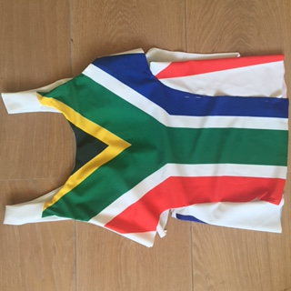**Ladies** :

|  |  |  |  |  |  |  |
| --- | --- | --- | --- | --- | --- | --- |
| Item | XS | S | M | L | XL | Price |
| Skort - frill |  |  |  |  |  | R185 |
| Skort – Plain Bottle Green |  |  |  |  |  | R165 |
| Skort- Plain White |  |  |  |  |  | R165 |
| Skort – Printed |  |  |  |  |  | R195 |
| Racer back – White |  |  |  |  |  | R165 |
| Racer back – Bottle green |  |  |  |  |  | R165 |
| Racer back – SA Flag |  |  |  |  |  | R225 |
| Collared shirt – White |  |  |  |  |  | R225 |
| Collared shirt – Green /White |  |  |  |  |  | R225 |
| Collared shirt- Green/Gold |  |  |  |  |  | R225 |
| Dress- Collared  (with shorts) |  |  |  |  |  | R350 |
| Dress - Asymmetric neckline |  |  |  |  |  | R350 |
| 1 or 2  Cap |  |  |  |  |  | R75 |
| Socks |  |  |  |  |  | R35 |
| Tracksuit |  |  |  |  |  | R495 |
| Warm up Top |  |  |  |  |  | R250 |
| Postage |  |  |  |  |  | R |
| **Total** |  |  |  |  |  | R |

Name: __________________________________________________________________________________________

Cell: ____________________________________________________________________________________________

Postal Address: _______________________________________________________________________________

__________________________________________________________________________________________________

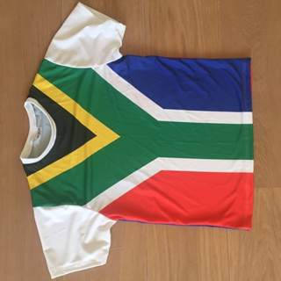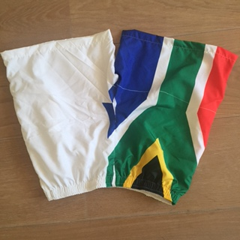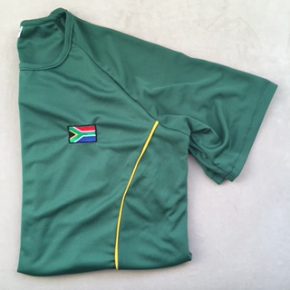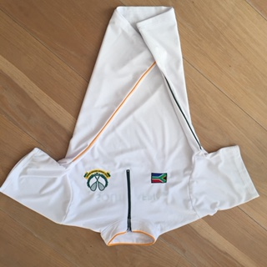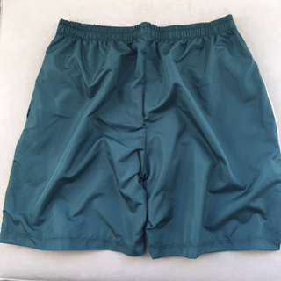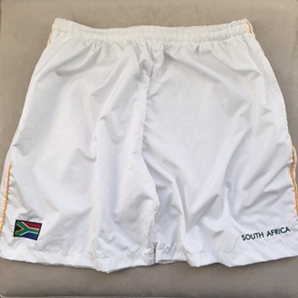**Mens**:

|  |  |  |  |  |  |  |
| --- | --- | --- | --- | --- | --- | --- |
| Item | S | M | L | XL | XXL | Price |
| Shorts -White |  |  |  |  |  | R150 |
| Shorts- Bottle Green |  |  |  |  |  | R150 |
| Shorts –SA Flag |  |  |  |  |  | R200 |
| Shirt- Zip Up |  |  |  |  |  | R185 |
| Crew neck- Bottle Green |  |  |  |  |  | R175 |
| (SAME AS GREEN) Crew Neck – White  IN WHITE |  |  |  |  |  | R175 |
| Crew neck – SA Flag |  |  |  |  |  | R225 |
| Collared shirt – White |  |  |  |  |  | R235 |
| Collared shirt – Green /White |  |  |  |  |  | R235 |
| Collared shirt- Green/Gold |  |  |  |  |  | R235 |
| 1 or 2  Cap |  |  |  |  |  | R75 |
| Socks |  |  |  |  |  | R35 |
| Tracksuit |  |  |  |  |  | R495 |
| Warm up Top |  |  |  |  |  | R250 |
| Postage |  |  |  |  |  | R |
| **Total** |  |  |  |  |  | R |

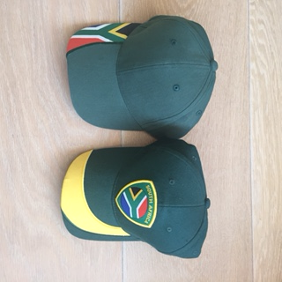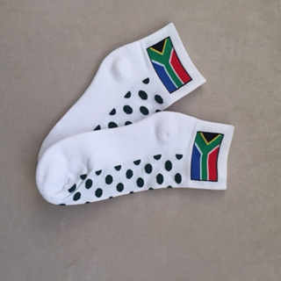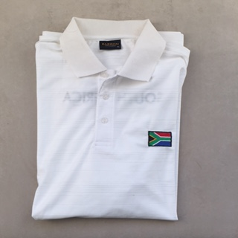

Name: __________________________________________________________________________________________

Cell: ____________________________________________________________________________________________

Postal Address: _______________________________________________________________________________

__________________________________________________________________________________________________